# A PROJECT REPORT

# ON

**HANDWRITTEN CHARACTER RECOGNITION USING CNN**

**Submitted to Krishna University, Machilipatnam in partial**

**Fulfillment of the requirements for the award of degree**

## Of

**MASTER OF COMPUTER APPLICATIONS**

## By

## NAGA MAHESWARI(Y21MCA015)

## UNDER ESTEEMED GUIDANCE OF

**Mrs. Dr .R.P.L.D.B.POONAM MCA, M.Tech, Ph.D**

## DEPARTMENT OF COMPUTER APPLICATIONS ANDHRA LOYOLA COLLEGE



**“A College with potential for Excellence”-UGC Re-accredited at ‘A++’Grade-NAAC**

## Affiliated to Krishna University, Machilipatnam, Krishna district-520008 2021-2023

**ANDHRA LOYOLA COLLEGE**

**DEPARTMENT OF**

**MASTER OF COMPUTER APPLICATIONS**



**CERTIFICATE**

This is to certify that the project work entitled, **“Handwritten character recognition using cnn ”**  submitted by **A.NAGA MAHESWARI** bearing **Regd. No : Y21MCA015 i**n partial fulfilment of the requirements for the award of the degree of **MASTER OF COMPUTER APPLICATIONS** from Krishna University, is a beneficed work to the best of my knowledge and may be placed before the examination board for their consideration.

## LECTURER INCHARGE HEAD OF THE DEPARTMENT

**Mrs. Dr .R.P.L.D.B.Poonam Mrs. Dr .R.P.L.D.B.Poonam**

**EXTERNAL EXAMINER**

# ORGANIZATION PROFILE

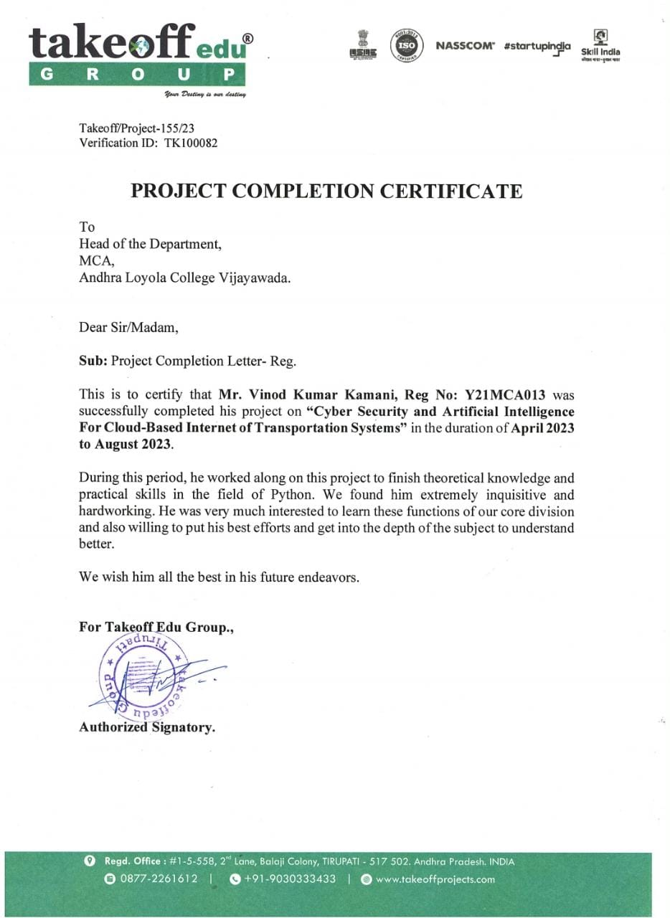

## DECLARATION

This is to declare that the project report entitled “**Handwritten character recognition using cnn”** done by me in is an authentic work carried out for the partial fulfilment of the requirements for the award of the degree of MCA in computer applications under the guidance of **Mrs. Dr .R.P.L.D.B.Poonam MCA, M.Tech(IT),Ph.D** lecture in Head Of the Department of MCA . The matter embodied in this project work has not been submitted earlier for award of an degree the best of my knowledge and belief.

## Signature of the student

## A.NAGA MAHESWARI

**Regd . No : Y21MCA015**

**Andhra Loyola College**

# ACKNOWLEDGEMENT

It has been a great pleasure doing project work at Andhra Loyola college. I express profound gratitude to **Rev .Fr. K.M. Prabhudas, S.J M.A,M.Phil.,(Ph.D)** Vice-principal(PG), Andhra Loyola College, Vijayawada, who gave me an opportunity to work out my project .I wish to express my special thanks to **Mrs. Dr .R.P.L.D.B.Poonam MCA, M.Tech(IT),Ph.D** lecturer of MCA , ALC Vijayawada .For his constant encouragement throughout this course

## A.NAGA MAHESWARI

## Regd. No:Y21MCA015

ABSTRACT

# ABSTRACT:

In this project we present an innovative method for offline handwritten character detection using deep neural networks. In today world it has become easier to train deep neural networks because of availability of huge amount of data and various Algorithmic innovations which are taking place. Now-a-days the amount of computational power needed to train a neural network has increased due to the availability of GPU’s and other cloud-based services like Google Cloud platform and Amazon Web Services which provide resources to train a Neural network on the cloud. We have designed a image segmentation based Handwritten character recognition system. In our system we have made use of OpenCV for performing Image processing and have used TensorFlow for training a neural Network. We have developed this system using python programming language.

**KEYWORDS:** Handwritten, Character, segmentation.

# INDEX

**CONTENTS PAGE NO**

## 1 INTRODUCTION------------------------------------ 10

1.1 INTRODUCTION ………………………………………… 11

1.2 EXISTING SYSTEM……………………………………… 11

1.3 PROPOSED SYSTEM…………………………………… 12

* 1. GOALS 12
  2. DESCRIPTION OF PROJECT 13
  3. SOFTWARE AND HARDWARE SPECIFICATIONS 13
  4. SOFTWARE METHODOLOGY 14

1. STUDY PHASE 31

2.1 INTRODUCTION TO ANALYSIS------------------------------ 33

2.2 FEASIBILITY STUDY-------------------------------------------- 33

* 1. DATA COLLECTION--------------------------------------------- 34

2.4 DATA ANALYSIS 37

* 1. UML DIAGRAMS 40

3 DESIGN PHASE 48

3.1 DESIGN PROCESS 53

3.2 DESIGN AXIOMS 55

3.3 REFININIG ATTRIBUTES 55

3.4 REFINING METHODS 55

3.5 REFINING CLASS DIAGRAMS---------------------------------------- 56

3.6 DESIGN OF VIEW LAYER 58

4.IMPLEMENTATION AND SYSTEM TESTING------------ 59

4.1 FORNTEND FEATURES------------------------------------------ 60

4.2 BACKEND FEATURES-------------------------------------------- 65

4.3 TEST CASES 67

5.SCREENSHOTS--------------------------------------------------- 69

6.CONCLUSION----------------------------------------------------- 78

7.FUTURE ENHANCEMENT------------------------------------ 80

8.BIBILOGRAPHY-------------------------------------------------- 82



* 1. **INTRODUCTION**

Handwritten character recognition is a fundamental task in the field of computer vision and pattern recognition. It involves the development of algorithms and techniques to automatically recognize and interpret handwritten characters or symbols. Handwritten character recognition has numerous applications, such as postal automation, document digitization, signature verification, and text recognition in historical manuscripts.

Convolutional Neural Networks (CNNs) have emerged as a powerful and widely used approach for handwritten character recognition. CNNs are a type of deep learning architecture specifically designed to analyze visual data. They have been highly successful in various computer vision tasks, including image classification, object detection, and segmentation.

The CNN architecture consists of multiple layers, including convolutional layers, pooling layers, and fully connected layers. In the context of handwritten character recognition, the input to the CNN is an image of a handwritten character. The convolutional layers apply filters to extract local features from the input image, capturing important patterns such as edges, corners, and textures. The pooling layers reduce the spatial dimensions of the feature maps, retaining the most salient information. The fully connected layers at the end of the network process the high-level features and produce the final classification output.

In conclusion, handwritten character recognition using CNNs has proven to be a highly effective and efficient approach. The combination of deep learning and convolutional neural networks has revolutionized the field, enabling robust and accurate recognition of handwritten characters in various applications.

### EXISTING SYSTEM

### Existing method:

Convolutional Neural Networks (CNNs) have become the state-of-the-art method for handwritten character recognition. They have achieved remarkable success in this domain by automatically learning discriminative features from raw input data. CNNs have demonstrated superior performance compared to traditional machine learning approaches, such as Support Vector Machines (SVMs) or Hidden Markov Models (HMMs), which often require handcrafted feature engineering.

**Disadvantages:**

Large training data requirements

Computational complexity

Sensitivity to data quality and variations

* 1. **PROPOSED SYSTEM**

Handwritten character recognisation(HCR) is a mechanism which enables to translate different types of documents into analysable, editable and searchable data. An ultimate aim of HCR is to emulate human reading capabilities in such a way that the machine can read, edit and interact with text as a human in short time. In this paper, our aim is to develop an efficient HCR system using CNN. To test the HCR system NIST database has been used. To assess the performance of CNN algorithm, we experimented with the dataset NIST and found the accuracy of handwritten characters. The handwritten characters in NIST are given as images. The images are split into training and testing sets.

**Advantages:**

High accuracy

End-to-end learning

Generalization capability

* 1. **GOALS:**

When setting goals for a handwritten character recognition system using CNNs, consider the following objectives:

Data Collection and Preparation

Model Selection and Architecture

Training and Validation

Accuracy and Performance

Hyperparameter Tuning

Error Analysis

Deployment and User Interface

**DESCRIPTION OF PROJECT**

The Handwritten Character Recognition using CNN project aims to develop an intelligent system that can accurately recognize and interpret handwritten characters from various sources. The project leverages the power of Convolutional Neural Networks (CNNs) to create a robust and efficient model capable of accurately identifying characters even in the presence of variations in handwriting styles, sizes, and orientations.

**SOFTWARE AND HARDWARE SPECIFICATION**S

Hardware Specifications:

Hard Disk : 100gb

RAM : 4gb

Software Specifications:

Operating system : Windows 7-Windows 11

Coding Language : Python

Run Environment : Juypter, Google colob, python

**Functional and Non-functional requirements:**

**Functional Requirements:**

The functional requirements for a system describe what system do.

1.The developed system should recognize handwritten English character present in the image.

2.System shall show the error message to the user when given input is not in the required format.

3.System must provide the quality of service to user.

4.System must provide accuracy for character recognition.

**Non-Functional Requirements:**

Non-functional requirements outline the qualities and constraints that describe how a system should perform, rather than specific features or functionalities. Here are some non-functional requirements that could apply to a Handwritten Character Recognition project using Convolutional Neural Networks (CNNs):

Accuracy Requirement

Speed and Latency

Scalability

Robustness and Variability

Usability and User Experience

Security and Privacy

Compatibility

Maintainability

Interoperability

Reliability and Availability

Adaptability

**1.7 SOFTWARE MEDTHODOLOGY**